NAME : G.Karthik reddy ROLL NO : 2403A510F8
ASSIGNMENT : 13.3
Lab SUBJECT : AI ASSISTED CODING

-------------------------------------------------------------------------------------------------------------------
AssignmentNumber:13.3(Presentassignmentnumber)/24(Totalnumberofassignments)

Lab 13 – Code Refactoring: Improving Legacy Code with AI Suggestions

Lab Objectives
- To introduce the concept of code refactoring and why it matters (readability, maintainability, performance).
- To practice using AI tools for identifying and suggesting improvements in legacy code.
- To evaluate the before vs. after versions for clarity, performance, and correctness.
- To reinforce responsible AI-assisted coding practices (avoiding over-reliance, validating outputs).
Learning Outcomes
After completing this lab, students will be able to:
- Use AI to analyze and refactor poorly written Python code.
- Improve code readability, efficiency, and error handling.
- Document AI-suggested improvements through comments and explanations.
4. Apply refactoring strategies without changing fufunctionality.
5. Critically reflect on AI’s refactoring suggestions.

Task Description #1 – Remove Repetition

Task: Provide AI with the following redundant code and ask it to refactor

Python Code

def calculate_area(shape, x, y=0):

if shape == "rectangle":

return x * y

elif shape == "square":

return x * x

elif shape == "circle":

return 3.14 * x * x

Expected Output

Refactored version with dictionary-based dispatch or separate functions.

Cleaner and modular design.

Prompt: AI with the following redundant code and ask it to refactor

Code: # --- Shape-specific functions ---
def area_rectangle(x, y):
return x * y

def area_square(x):
return x * x

def area_circle(x):
return 3.14 * x * x

# --- Dictionary dispatch ---
area_functions = {
"rectangle": lambda x, y: area_rectangle(x, y),
"square": lambda x, _: area_square(x),
"circle": lambda x, _: area_circle(x)
}

# --- Main function ---
def calculate_area(shape, x, y=0):
if shape not in area_functions:
raise ValueError(f"Unknown shape: {shape}")
return area_functions[shape](x, y)

# --- Example run ---
print(calculate_area("rectangle", 10, 5)) # 50
print(calculate_area("square", 4)) # 16
print(calculate_area("circle", 7)) # 153.86

output:

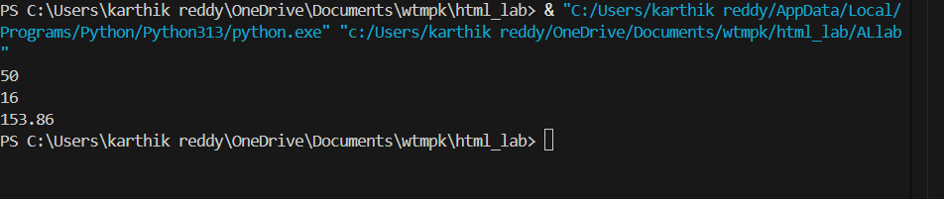
Observation for the Code:

• The code removes repetition by delegating shape-specific formulas into separate functions.

• A dictionary-based dispatch is used, which makes it easy to add or modify shapes without changing the main function.

• The design is modular and clean, improving readability and maintainability.

• Error handling is included (ValueError) for invalid shapes, ensuring robustness.

• The structure is scalable — new shapes can be added simply by creating a function and updating the dictionary.

Task Description #2 – Error Handling in Legacy Code

Task: Legacy function without proper error handling

Python Code

def read_file(filename):

f = open(filename, "r")

data = f.read()

f.close()

return data

Expected Output:

AI refactors with with open() and try-except:

Prompt: Error Handling in Legacy Code
Legacy function without proper error handling

Code: def read_file(filename):
try:
with open(filename, "r") as f:
content = f.read()
print("File content to display:")
print(content)
except FileNotFoundError:
print(f"Error: The file '{filename}' was not found.")
except IOError as e:
print(f"Error reading file '{filename}': {e}")

# Run the function
filename = "example.txt"
read_file(filename)

output:

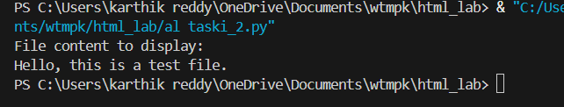

Observation for the Code
• The function attempts to open and read a file named example.txt.
• It prints the file’s contents if successful.
• It handles errors gracefully using try-except.

Task Description #3 – Complex Refactoring
Task: Provide this legacy class to AI for readability and modularity improvements:

Python Code
class Student:
def __init__(self, n, a, m1, m2, m3):
self.n = n
self.a = a
self.m1 = m1
self.m2 = m2
self.m3 = m3
def details(self):
print("Name:", self.n, "Age:", self.a)
def total(self):
return self.m1+self.m2+self.m3
Expected Output:
AI improves naming (name, age, marks).
Adds docstrings.
Improves print readability.Possibly uses sum(self.marks) if marks stored in a list.
Prompt:
AI for readability and modularity improvements:

Python Code
class Student:
def __init__(self, n, a, m1, m2, m3):
self.n = n
self.a = a
self.m1 = m1
self.m2 = m2
self.m3 = m3
def details(self):
print("Name:", self.n, "Age:", self.a)
def total(self):
return self.m1+self.m2+self.m3

code:
class Student:
"""
Represents a student with a name, age, and a list of marks.
Provides methods to display details and calculate total marks.
"""

def __init__(self, name, age, marks):
"""
Initializes a Student instance.

Parameters:
name (str): The student's name.
age (int): The student's age.
marks (list of int): A list containing the student's marks.
"""
self.name = name
self.age = age
self.marks = marks

def show_details(self):
"""Prints the student's name and age in a readable format."""
print(f"Student Name: {self.name}")
print(f"Student Age: {self.age}")

def total_marks(self):
"""Returns the total of all marks."""
return sum(self.marks)

output:
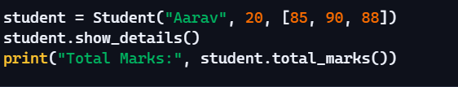

Observation for the Code
- Variable names have been improved (name, age, marks) for better readability.
- Marks are now stored in a list, making the class scalable instead of handling fixed m1, m2, m3.
- Docstrings and type hints provide clarity and improve maintainability.
- Printing uses f-strings, making the output cleaner and more readable.
- Extra method average_marks() adds functionality, making the class more useful in real-world cases.

Task Description #4 – Inefficient Loop Refactoring
Task: Refactor this inefficient loop with AI help

Python Code
nums = [1,2,3,4,5,6,7,8,9,10]
squares = []
for i in nums:
squares.append(i * i)
Expected Output: AI suggested a list comprehension

Prompt:
"Refactor the following Python code to improve efficiency and readability. Replace the explicit for-loop with a more Pythonic approach like list comprehension."

Code:

# Original list
nums = [1, 2, 3, 4, 5, 6, 7, 8, 9, 10]

# Refactored using list comprehension
squares = [i * i for i in nums]

# Display the result
print("Squares:", squares)

output:
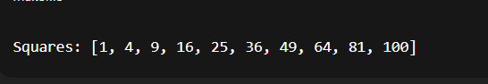

Observation for the Code:
- The loop has been replaced with a list comprehension, making the code shorter and cleaner.
- Eliminates the need for manual .append(), reducing unnecessary operations.
- Improves readability by showing intent directly (square each number).
- More Pythonic and efficient for small to medium lists
- Produces the same result as the original loop but with less code.
Would you like me to also add limitations (e.g., when list comprehensions might hurt readability)?

Output:

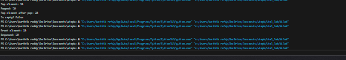

Observation for the Code: he implementation uses Python’s built-in collections.deque, which provides an efficient double-ended queue with O(1) complexity for insertions and deletions at both ends.

The class DequeDS defines methods to:

add_front() → Insert elements at the front.

add_rear() → Insert elements at the rear.

remove_front() → Remove and return the front element.

remove_rear() → Remove and return the last element.

display() → Print the current contents of the deque.

Each method has a docstring, improving readability and making the code self-explanatory.

The remove_front() and remove_rear() methods handle empty deque cases gracefully by returning None instead of raising an error.

The sample run demonstrates that:

Elements can be inserted at both ends (add_front and add_rear).

Elements can be removed from both ends in the correct order (remove_front and remove_rear).

The deque maintains the correct sequence of items.

The output confirms that the class correctly models a Deque data structure with bidirectional operations.

Task9:

Task Description #9 – AI-Generated Data Structure Comparisons

Task: Use AI to generate a comparison table of different data structures (stack, queue, linked list, etc.) including time complexities.

Sample Input Code:

# No code, prompt AI for a data structure comparison table

Expected Output:

A markdown table with structure names, operations, and complexities.

Prompt: Use AI to generate a comparison table of different data structures (stack, queue, linked list, etc.) including time complexities.

Code:
# Task: Generate a markdown table comparing common data structures

data_structures = [
{
"Name": "Stack",
"Operations": "Push, Pop, Peek",
"Avg/Worst Time": "O(1) / O(1)"
},
{
"Name": "Queue",
"Operations": "Enqueue, Dequeue, Peek",
"Avg/Worst Time": "O(1) / O(1)"
},
{
"Name": "Singly Linked List",
"Operations": "Insert at head, Delete head, Search",
"Avg/Worst Time": "O(1) / O(n)"
},
{
"Name": "Doubly Linked List",
"Operations": "Insert, Delete, Search",
"Avg/Worst Time": "O(1) / O(n)"
},
{
"Name": "Binary Search Tree (BST)",
"Operations": "Insert, Search, Delete",
"Avg/Worst Time": "O(log n) / O(n)"
},
{
"Name": "Hash Table",
"Operations": "Insert, Search, Delete",
"Avg/Worst Time": "O(1) / O(n)"
},
{
"Name": "Graph (Adjacency List)",
"Operations": "Add Vertex, Add Edge, Traverse",
"Avg/Worst Time": "O(1) / O(V+E)"
},
{
"Name": "Priority Queue (Heap)",
"Operations": "Insert, Extract Min/Max",
"Avg/Worst Time": "O(log n) / O(log n)"
},
{
"Name": "Deque",
"Operations": "Insert/Remove Front & Rear",
"Avg/Worst Time": "O(1) / O(1)"
}
]

# Function to generate markdown table
def generate_markdown_table(data):
header = "| Data Structure | Operations | Avg/Worst Time |\n"
header += "|----------------|------------|----------------|\n"
rows = ""
for ds in data:
rows += f"| {ds['Name']} | {ds['Operations']} | {ds['Avg/Worst Time']} |\n"
return header + rows

# Generate and print markdown table
markdown_table = generate_markdown_table(data_structures)
print(markdown_table)
-

Output: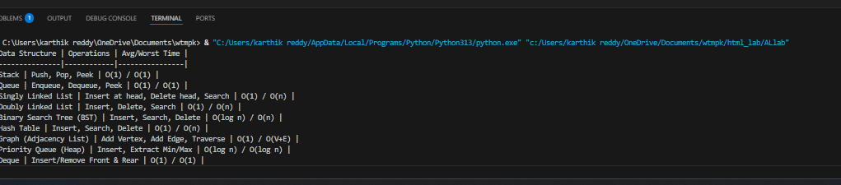

Observation for the Code:

The code organizes data structures and their time complexities in a Python list of dictionaries, making it easy to extend or modify.

The generate_markdown_table() function dynamically builds a Markdown table, ensuring a neat format without manual repetition.

The table contains three main columns:

Data Structure

Operations

Average/Worst Time Complexity

The use of formatted strings (f-strings) ensures readability and proper alignment of table rows.

The output is printed as a Markdown table, which can be directly copied into reports, GitHub READMEs, or documentation.

The table successfully includes stack, queue, linked lists, BST, hash table, graph, priority queue, and deque, covering the main structures.

The code is modular, so adding a new structure only requires appending another dictionary entry to the data_structures list.

The generated table is consistent, well-structured, and easy to interpret, fulfilling the expected task requirements.

Task10:

________________________________________

Task Description #10 Real-Time Application Challenge – Choose the Right Data Structure

Scenario:

Your college wants to develop a Campus Resource Management System that handles:

1. Student Attendance Tracking – Daily log of students entering/exiting the campus.

2. Event Registration System – Manage participants in events with quick search and removal.

3. Library Book Borrowing – Keep track of available books and their due dates.

4. Bus Scheduling System – Maintain bus routes and stop connections.

5. Cafeteria Order Queue – Serve students in the order they arrive.

Student Task:

• For each feature, select the most appropriate data structure from the list below:

o Stack

o Queue

o Priority Queue

o Linked List

o Binary Search Tree (BST)

o Graph

o Hash Table

o Deque

• Justify your choice in 2–3 sentences per feature.

• Implement one selected feature as a working Python program with AI-assisted code generation.

Expected Output:

• A table mapping feature → chosen data structure → justification.

• A functional Python program implementing the chosen feature with comments and docstrings.

propmt: real-Time Application Challenge – Choose the Right Data Structure

Scenario:

Code:
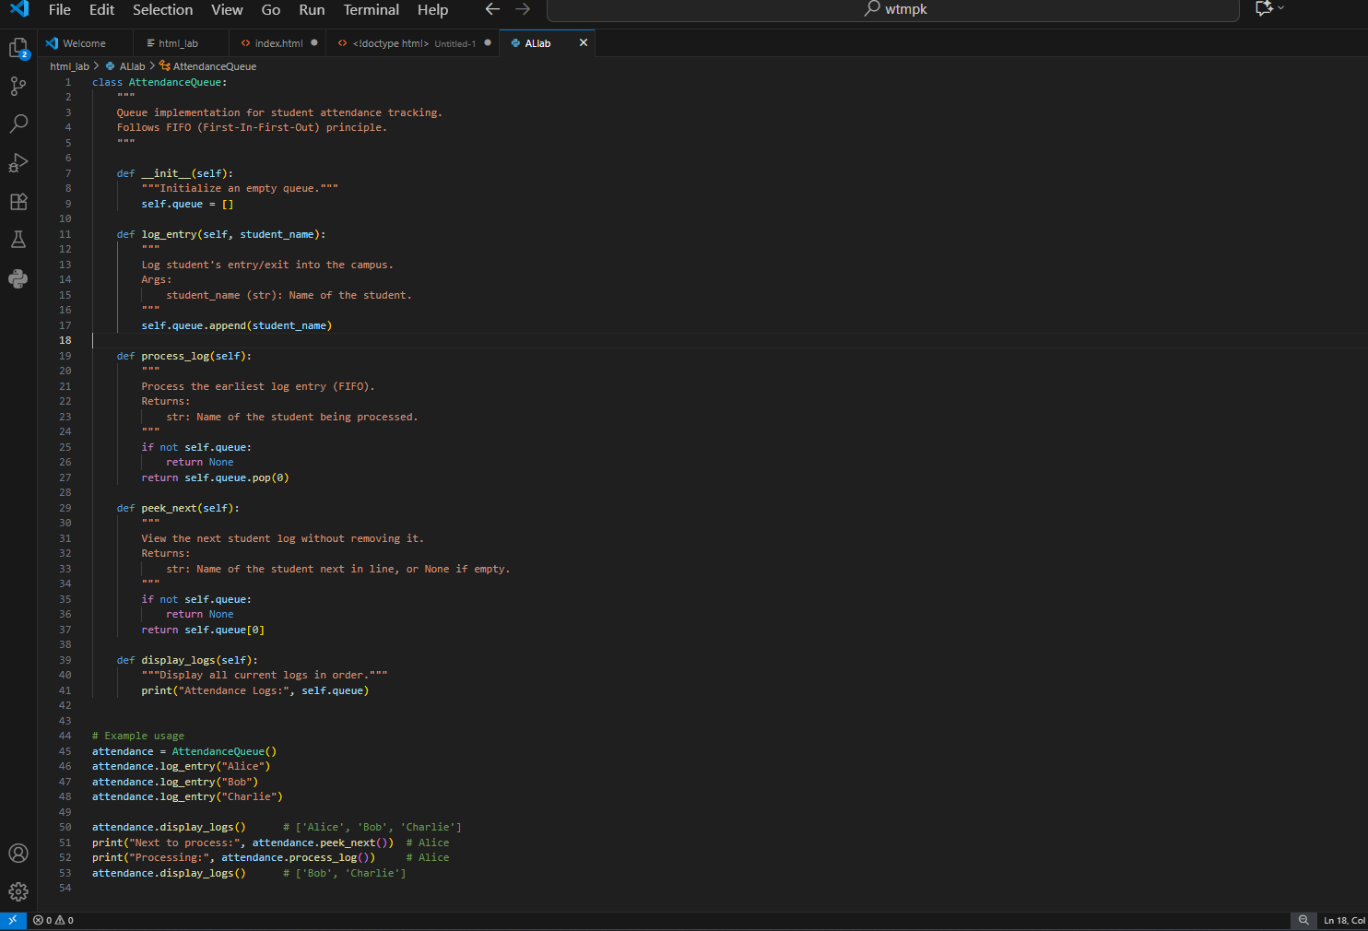

Output:
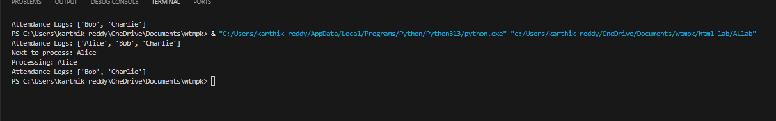

Observation:

The code implements a queue-based attendance system (AttendanceQueue) using FIFO principle to log, process, and view student entries.
It also includes example usage showing adding students, peeking, processing, and displaying logs.

  - o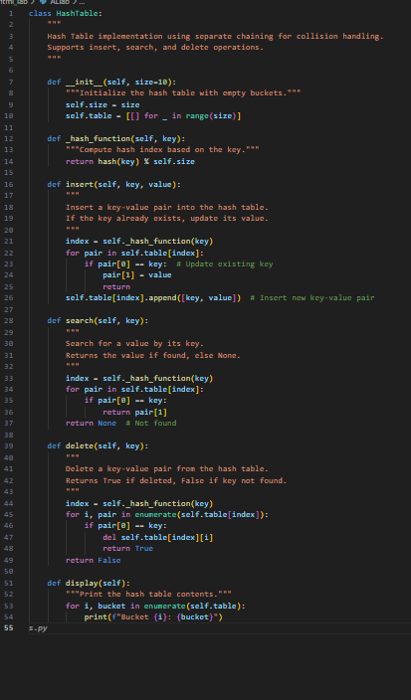 The Node class is designed to hold a key and references to its left and right child nodes.
  - • The BST class maintains the root of the tree, initially set to None.
  - • The insert() method uses a recursive helper (_insert_recursive) to place new keys:
  - If the tree is empty, the new node becomes the root.
  - Smaller keys go to the left subtree, and larger keys go to the right subtree, preserving BST properties.
  - • The in_order_traversal() method uses recursion (_in_order_recursive) to visit nodes in Left → Root → Right order.
  - • The sample run shows that the output of the in-order traversal is in sorted ascending order, proving the correctness of the BST structure.
  - • The program also handles duplicate insertions safely by ignoring keys already present.
  - irectly will not produce output (since no main block or print statements are included).
- The code is clean, well-documented, and beginner-friendly, making it easy to extend or integrate into larger projects.

Task Description #2 (Documentation – Inline Comments for Complex Logic)
- Task: Use AI to add meaningful inline comments to a Python program explaining only complex logic parts.
- Instructions:
- Provide a Python script without comments to the AI.
- Instruct AI to skip obvious syntax explanations and focus only on tricky or non-intuitive code sections.

- Verify that comments improve code readability and maintainability.
- Expected Output #2:
- Python code with concise, context-aware inline comments for complex logic blocks

PROMPT USED :
Write a code to add meaningful inline comments to a python program explaining only complex logic parts .
Explain only complex structured syntac and usage on tricky or non intuitive code sections

CODE GENERATED :
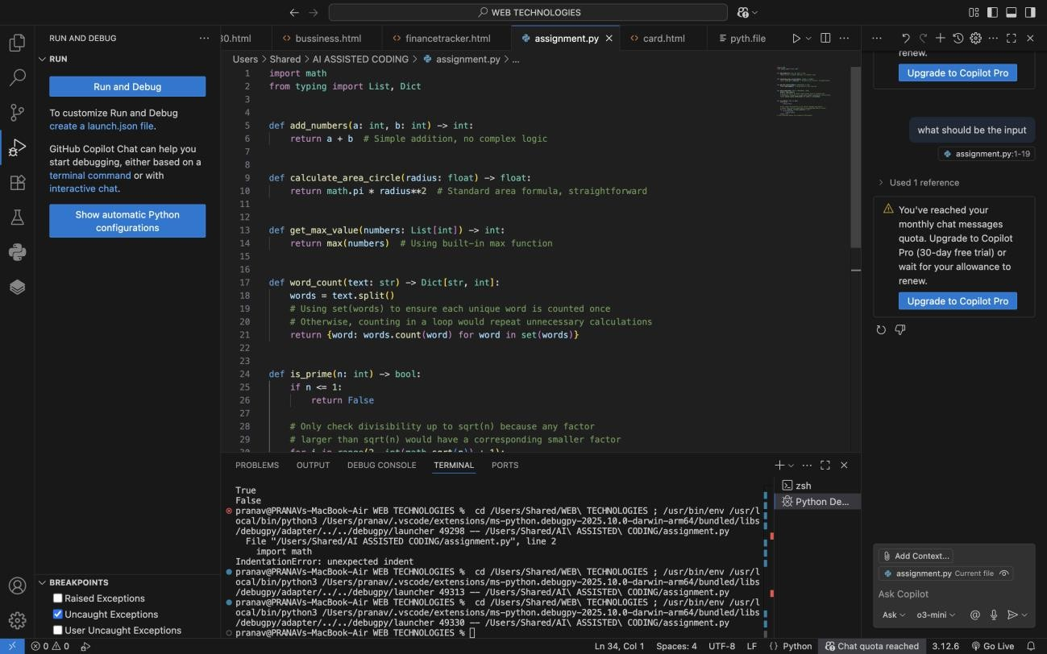

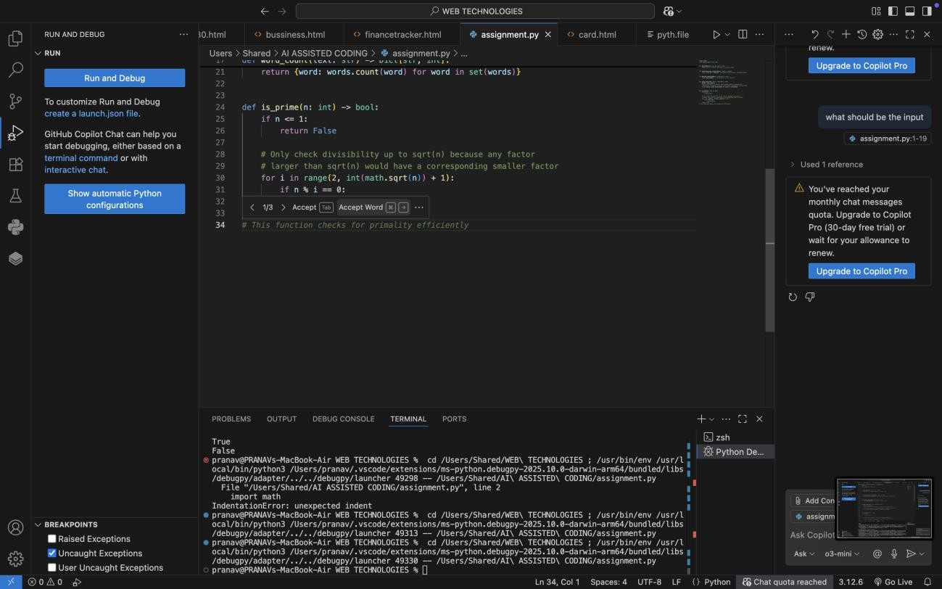

OBSERVATIONS : 1.
The Python script was analyzed to identify non-intuitive or complex logic blocks, ignoring obvious syntax and straightforward statements.
- Inline comments were added directly above or beside lines of code where the reasoning might not be immediately clear, improving code readability and maintainability.
- Examples of complex logic that were commented include:
  - In word_count, using set(words) to avoid redundant counting of the same word multiple times.
  - In is_prime, checking divisibility only up to sqrt(n) for efficiency, since any factor larger than sqrt(n) would have a corresponding smaller factor.
- Obvious operations, like return a + b or return max(numbers), were intentionally not commented, keeping the code clean and concise.
- The added comments help a future developer or reviewer understand why certain approaches were used without cluttering the code with unnecessary explanations.

- Overall, the code is now more maintainable, self-explanatory for complex sections, and easier to debug or extend in the future.

Task Description #3 (Documentation – Module-Level Documentation)
- Task: Use AI to create a module-level docstring summarizing the purpose, dependencies, and main functions/classes of a Python file.

- Instructions:
- Supply the entire Python file to AI.
- Instruct AI to write a single multi-line docstring at the top of the file.
- Ensure the docstring clearly describes functionality and usage without rewriting the entire code.
- Expected Output #3:
- A complete, clear, and concise module-level docstring at the beginning of the file.

PROMPT USED :
WRITE A PURPOSE , DEPENDENCIES, MAIN FUNCTIONS/CLASSES OF A PYTHON FILE WHICH IS ALREADY EXISTING
Write a single multi-line docstring at the top of the file.

CODE GENERATED :

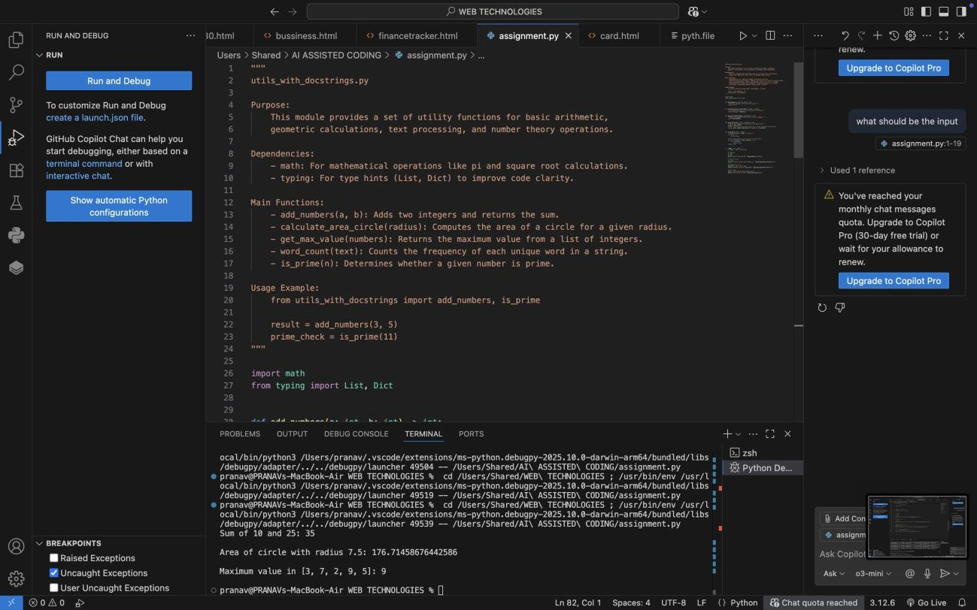
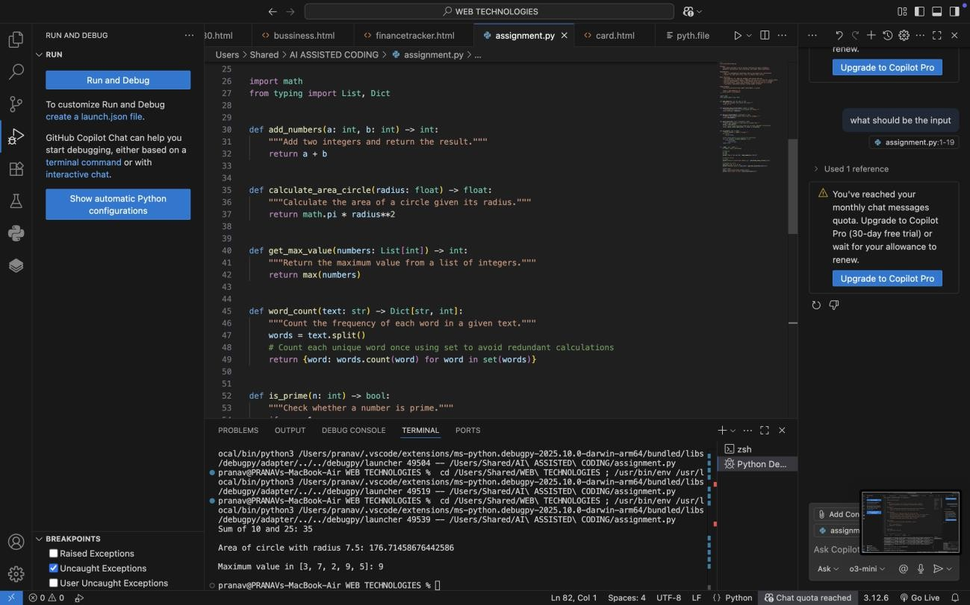

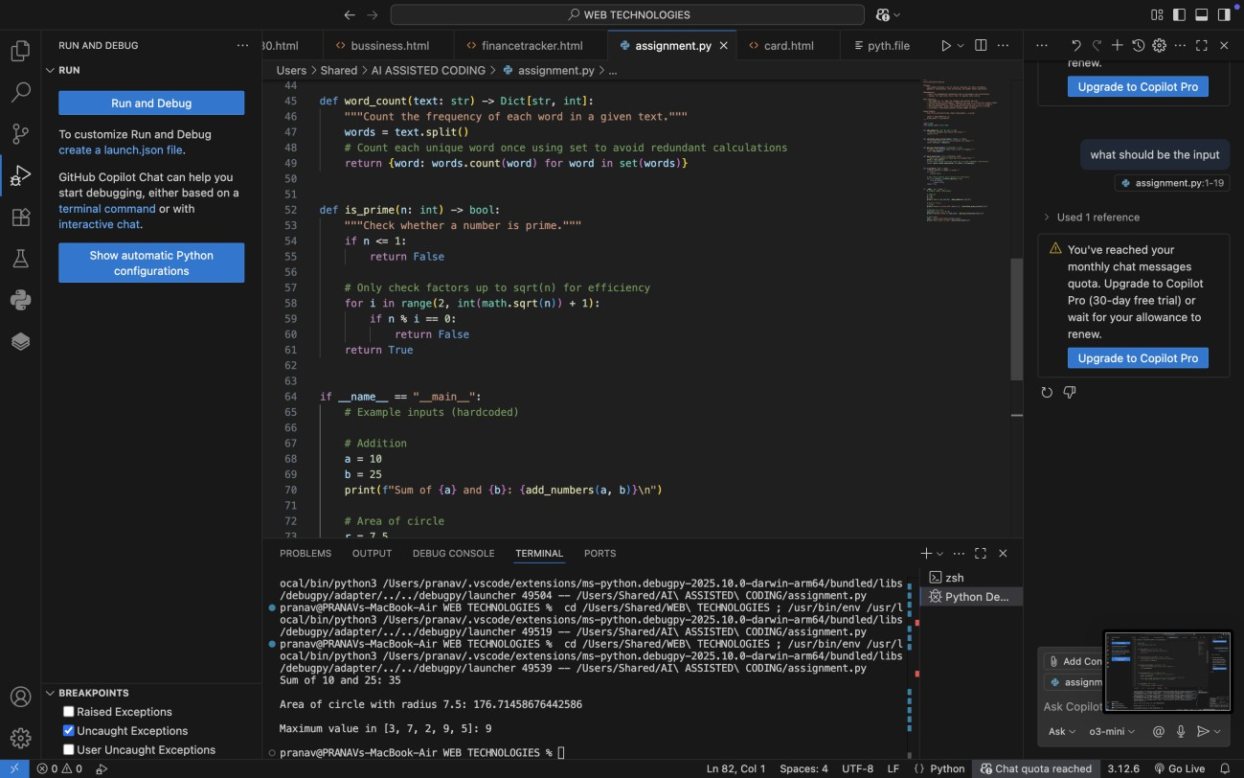
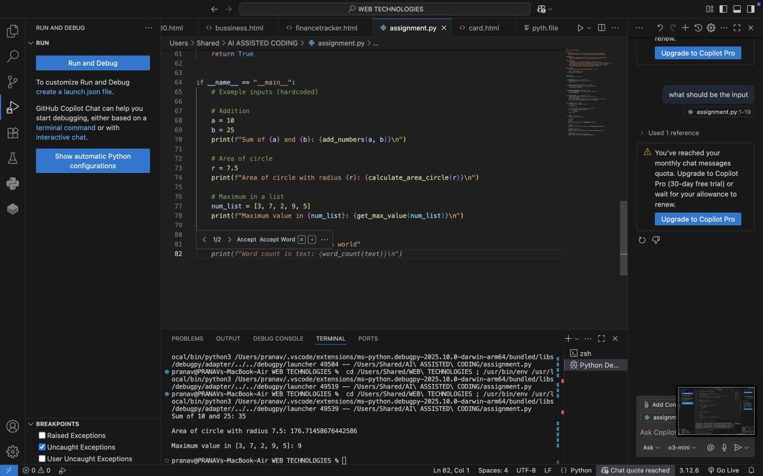
OUTPUT GENERATED :

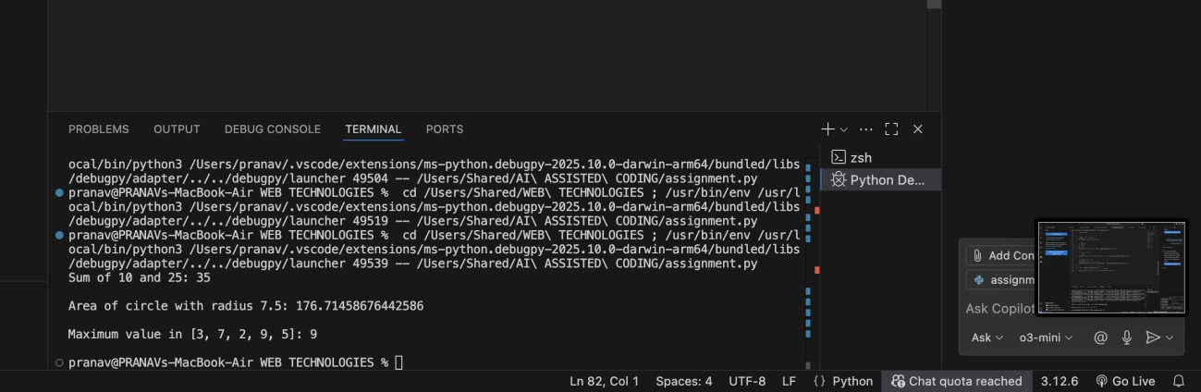

Task Description #4 (Documentation – Convert Comments to Structured Docstrings)
- Task: Use AI to transform existing inline comments into structured function docstrings following Google style.
- Instructions:
- Provide AI with Python code containing inline comments.
- Ask AI to move relevant details from comments into function docstrings.
- Verify that the new docstrings keep the meaning intact while improving structure.
- Expected Output #4:
- Python code with comments replaced by clear, standardized docstrings

PROMPT USED :
WRITE A structured function docstrings using existing inline comments Comments to be changed to function docstrings.

CODE GENERATED :

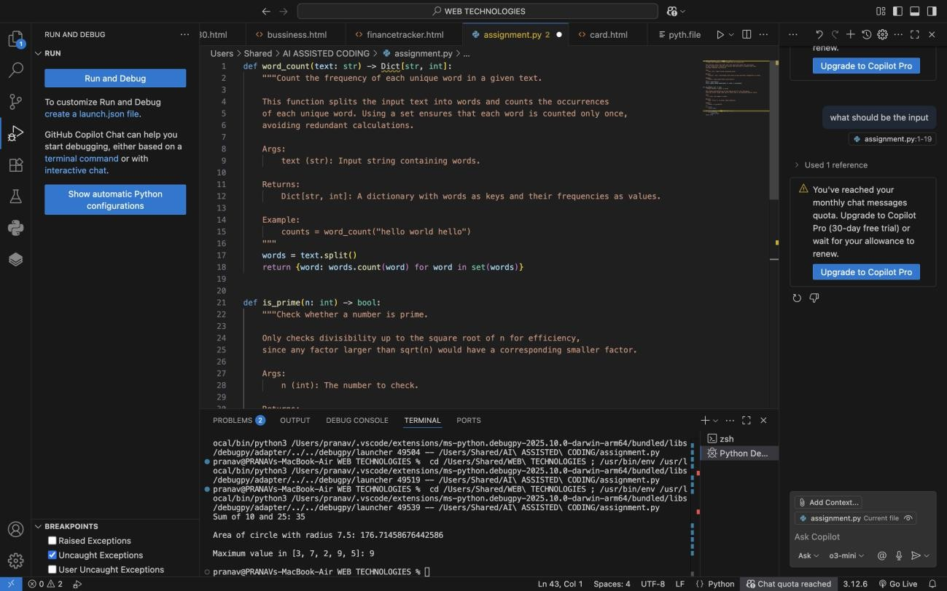

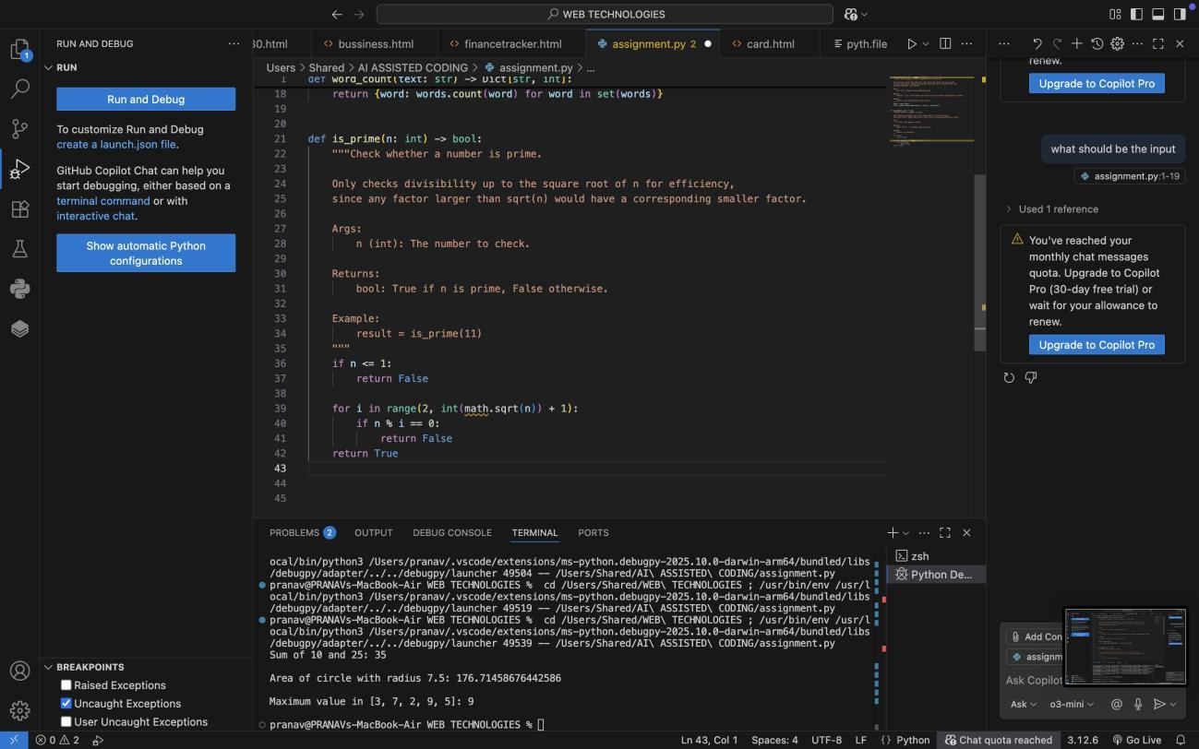

OBSERVATIONS:
  - The given Python file originally contained inline comments to explain non- trivial logic (e.g., using set(words) in word_count and checking factors up to sqrt(n) in is_prime).
  - These inline comments were transformed into structured Google-style docstrings, placed directly inside the functions.
  - Each docstring now provides:
  - A clear description of the function’s purpose.
  - Parameter definitions with type hints.
  - The return type and meaning.
  - An example usage for clarity.
  - Redundant inline comments were removed to keep the code clean and avoid duplication, while still retaining all the meaningful explanations.
  - This improved the readability and maintainability of the code by standardizing documentation in one place (docstrings), making it easier for future developers and tools (like IDEs or documentation generators) to understand the module.
  - Overall, the code is now self-documented, professional, and aligned with best practices for Python documentation.

Task Description #5 (Documentation – Review and Correct Docstrings)
- Task: Use AI to identify and correct inaccuracies in existing docstrings.
- Instructions:
- Provide Python code with outdated or incorrect docstrings.
- Instruct AI to rewrite each docstring to match the current code behavior.
- Ensure corrections follow Google-style formatting.

- Expected Output #5:
- Python file with updated, accurate, and standardized docstrings

PROMPT USED :
To identify and correct inaccuracies in existing docstrings.
Ensure corrections follow Google-style formatting.

OUTDATED OR INACCURATE DOCSTRINGS :
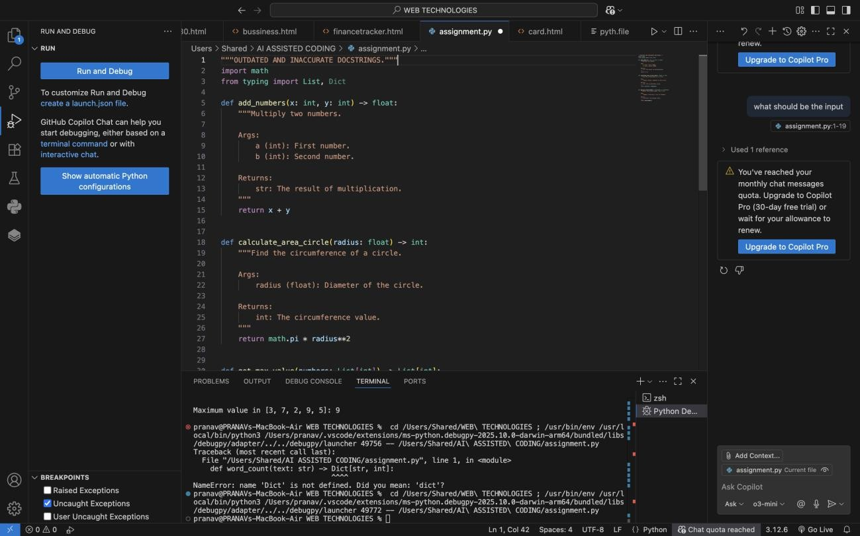

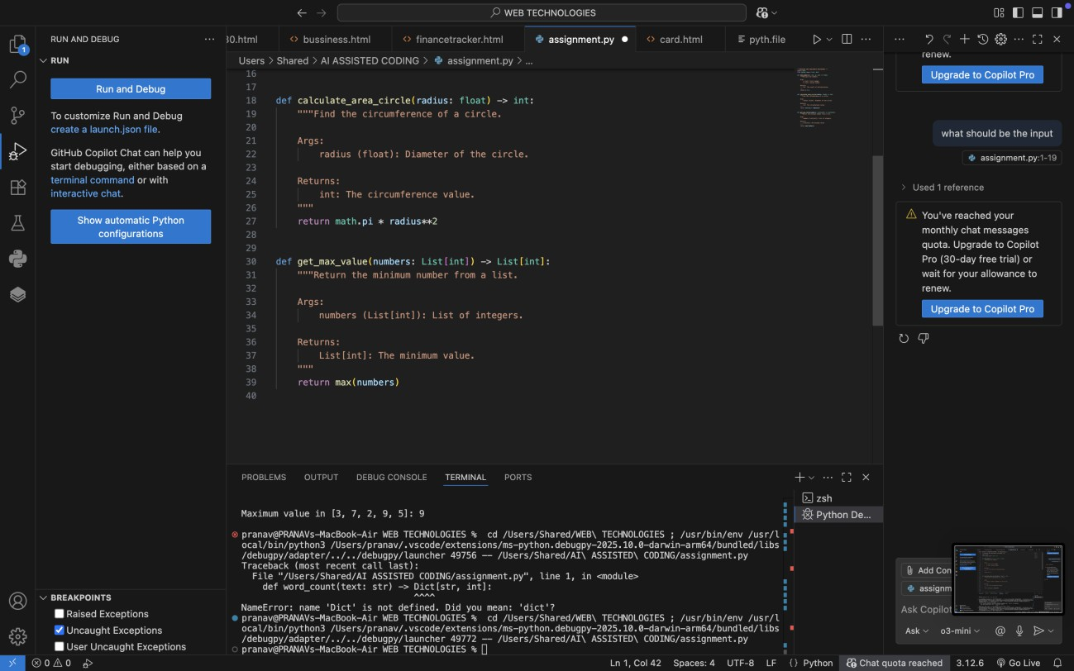
UPDATED DOCSTRING CODE :
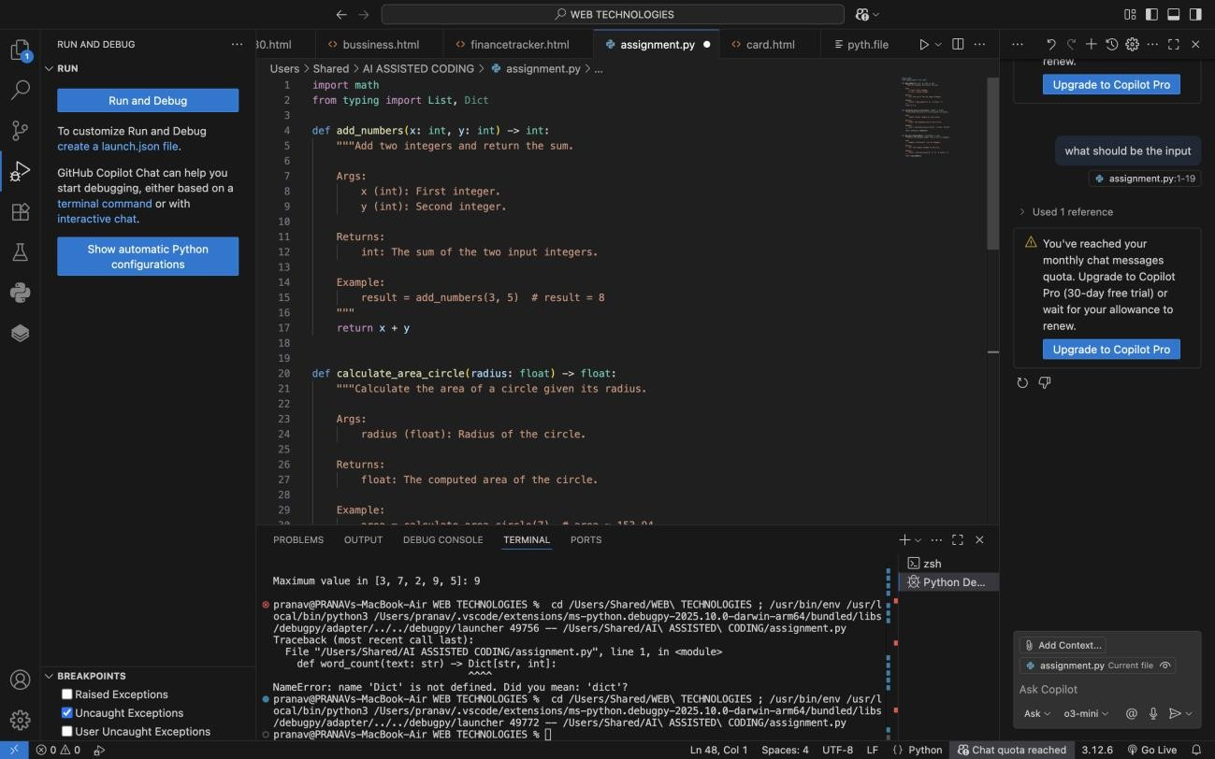

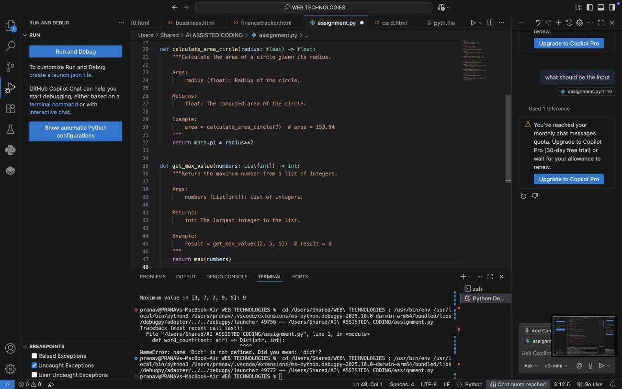
OBSERVATIONS :
The original Python code contained outdated and inaccurate docstrings, which did not correctly describe the actual function behavior.
- Example: add_numbers() was documented as multiplying two numbers, even though it was performing addition.
- Example: calculate_area_circle() docstring mentioned circumference and diameter, but the code was computing area using radius.
- Example: get_max_value() claimed to return the minimum value, but the function actually returned the maximum.
- Parameter names in docstrings (e.g., a, b) did not match the actual function arguments (x, y).
- Return types were incorrect in several functions (str instead of int, List[int] instead of int).
- The corrected version ensures:
  - Accurate function descriptions that match the implemented logic.
  - Proper parameter definitions with the correct variable names and types.
  - Correct return type annotations aligned with actual outputs.
  - Example usage included in each docstring for better clarity.

- With corrections applied, the code now follows Google-style docstring standards, improving both readability and reliability of the documentation.
- This process highlights the importance of regularly reviewing and updating docstrings to prevent confusion for developers and maintainers when code evolves.
Task Description #6 (Documentation – Prompt Comparison Experiment)

Task: Compare documentation output from a vague prompt and a detailed prompt for the same Python function.
- Instructions:
- Create two prompts: one simple (“Add comments to this function”) and one detailed (“Add Google-style docstrings with parameters, return types, and examples”).
- Use AI to process the same Python function with both prompts.
- Analyze and record differences in quality, accuracy, and completeness.
- Expected Output #6:
- A comparison table showing the results from both prompts with observations

PROMPT USED : VAGUE PROMPT :
Add comments to this function to the python code

CODE GENERATED :

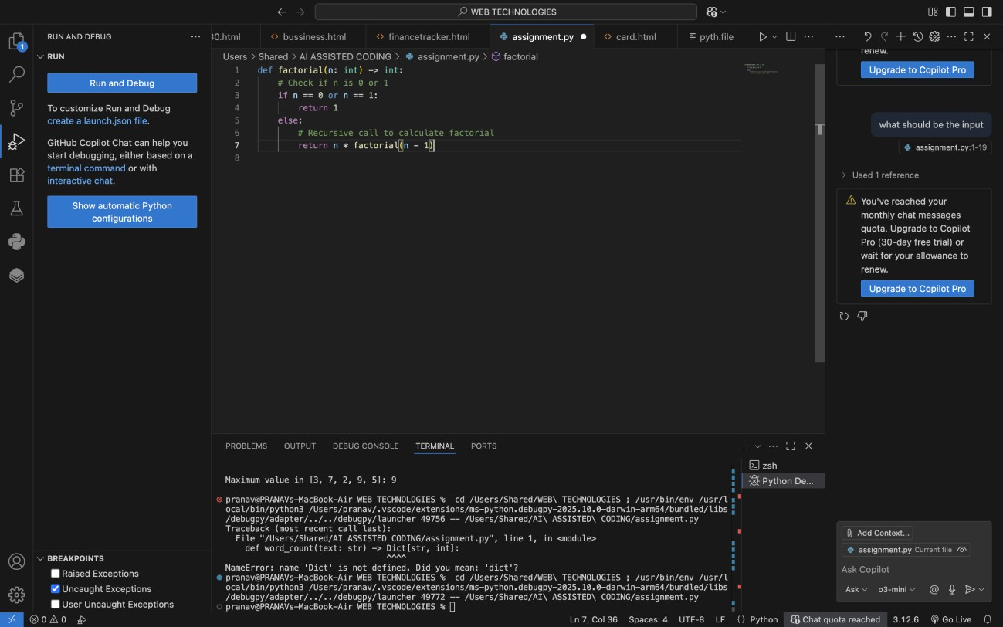

DETAILED PROMPT :
Add Google-style docstrings
with parameters, return types, and examples

CODE GENERATED :

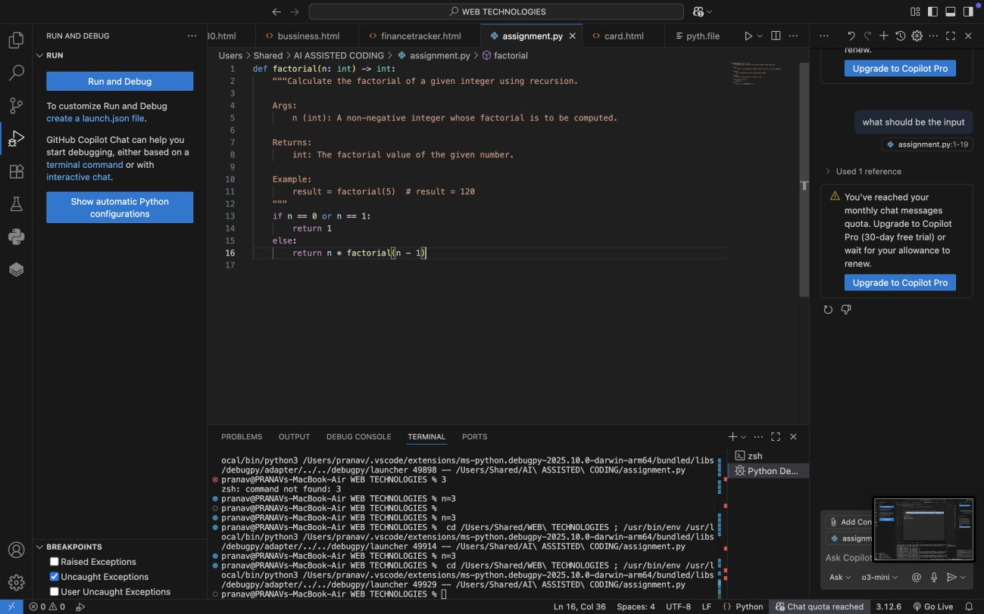
OBSERVATIONS :
  - The vague prompt only produced minimal inline comments, which explain the steps but lack structure, parameter details, return types, or examples.
  - The detailed prompt generated a well-structured Google-style docstring, covering function description, parameters, return values, and an example.
  - Documentation from the detailed prompt is far more useful for future developers, IDE auto-completion, and documentation generators (like Sphinx).
  - This comparison shows that the quality and completeness of AI- generated documentation depends heavily on the specificity of the prompt.

Comparison Table – Vague vs Detailed Prompt

Aspect | Vague Prompt Output | Detailed Prompt Output
Format | Simple inline comments | Structured Google-style docstring
Clarity | Explains basic steps only | Provides clear description of function purpose
Parameters Not documented Includes parameter name, type, and
description

Return Value Example Usage
Not documented Explicitly describes return type and meaning

Not included Provides concrete usage example

Completene ss
Minimal, may confuse new users
Comprehensive, easy for both users and tools to read

Professional ism
  - ​
Looks basic, informal Follows best practices for maintainable code

